**Project 6 Coin Detection – Part 1 – voting for centers**

Name: Satvik Matta Period: 5 Date: 2/10/2023

Did you name your file l061.cpp (Lower case L, then 061)? Yes

Did you create the edge matrix? Yes

Did you create the gradient direction matrix? Yes

Did you create the imagev.ppm (visual of votes)? Yes

Did you use Bresenham's line algorithm for voting? Yes

Did you test on the terminal/jupyterhub? Yes

Below for the easy image provided paste the imagev.ppm, imageCC.ppm you obtained running your code:

What are the 3 values you sed for lower/upper thresholds and also for the threshold for votes:

**Low Threshold:** 70

**High Threshold:** 200

**Vote Threshold:**

Default: 22

If height between 40% and 90% and width less than 40% of image: 1.8*22

If height between 40% and 90% and width greater than 40% of image: 1.5*22

**Optimizations:**

* Segmentation
* Max coin size

**To turn off all optimizations, just pass in a threshold value using -TC in the command line. This runs the basic algorithm. It will take much, much longer to run on the easy image provided!**

**imagev.ppm:**

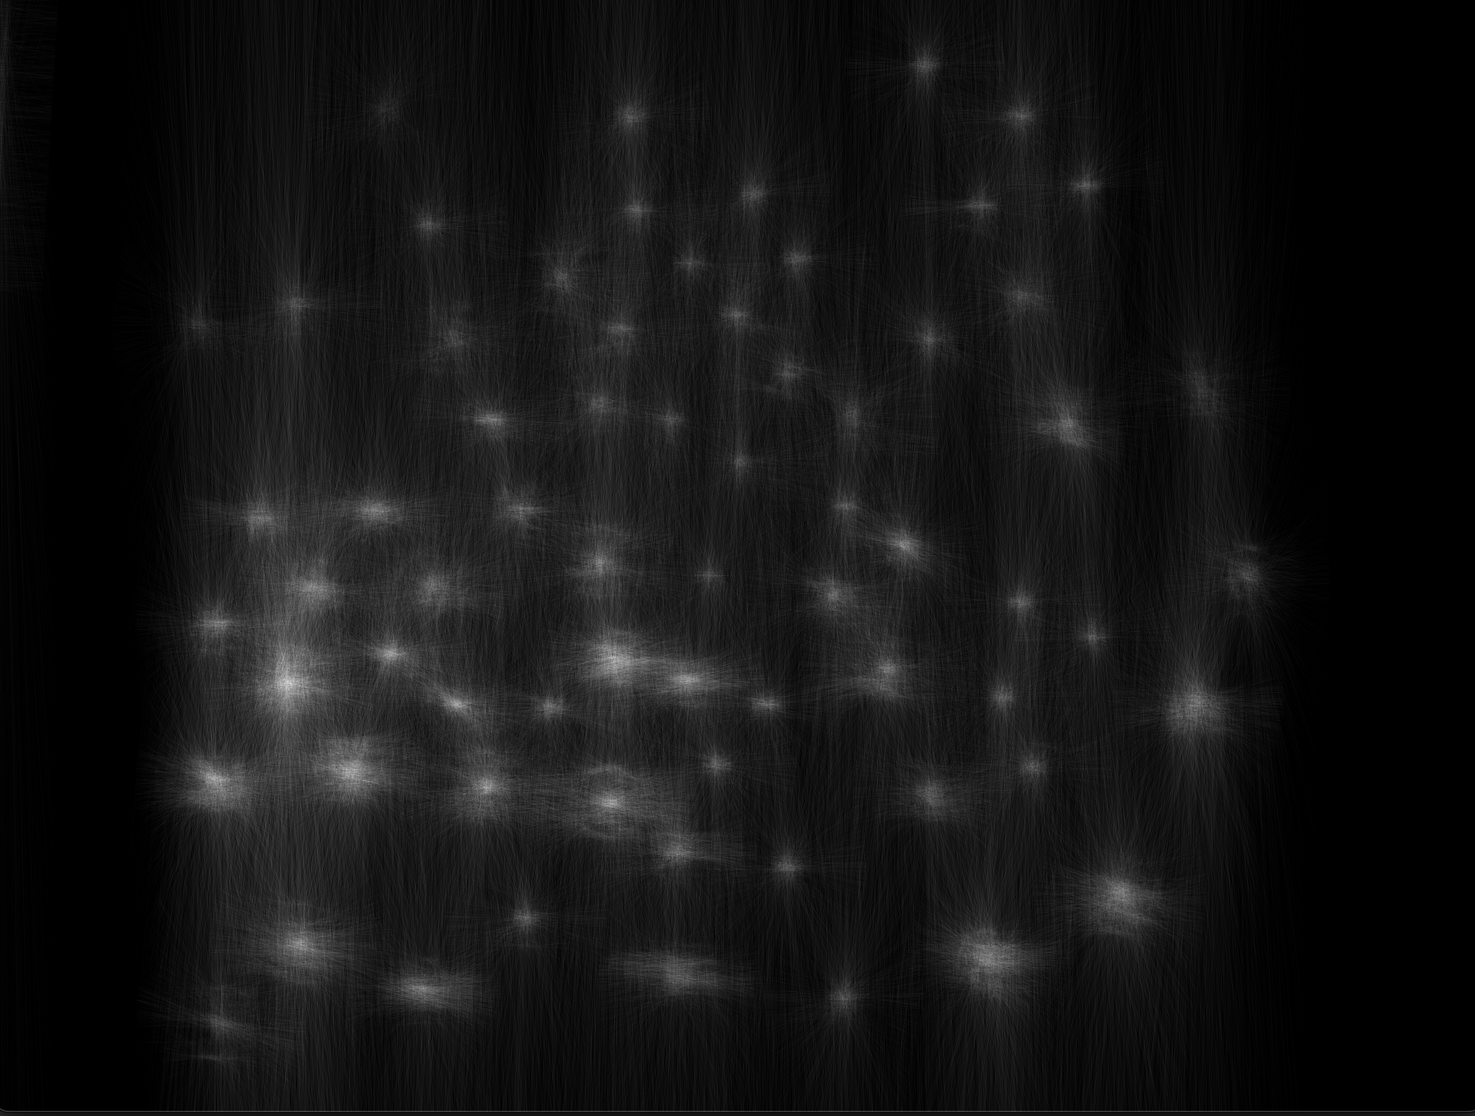

**imageCC.ppm:**

